

**MINI PROJECT REPORT**

**ON**

**“E- CANTEEN”**

**BY**

**YASH BHASKAR NARKHEDE**

**SAVITRIBAI PHULE PUNE UNIVERSITY**

**MASTERS OF COMPUTER APPLICATION**

**JSPM’s**

**Jayawant Institute of Management Studies**

**Tathawade, Pune-33**

**(NAAC Accredited “A” grade Institute, Approved by AICTE & Recognized by Savitribai Phule Pune University)**

**2021-23**

**JSPM’s**



**JAYAWANT INSTITUTE OF MANAGEMENT STUDIES**

(Approved by AICTE, New Delhi, Recognized by Gov, of Maharashtra

& Affiliated to Pune University)

**S. No. 80/2, Pune-Mumbai Bypass Highway, Tathawade, Pune – 411033.**

**Phone:** +91-20-64731454/55 **Telefax:** +91-20-22933424.

**E-mail**: [director_jims@tjspm.edu.in](mailto:director_jims@tjspm.edu.in) **Website**: [www.jspm.edu.in](http://www.jspm.edu.in)

AISHE Code: C-60096

Accredited by NAAC With "A" Grade

**Dr. Prof. T. J. Sawant Dr. Bipin Bankar**

**B.E.(Elec.), PGDM, Ph.D B.Com, MBA, Ph. D.**

**Founder- Secretary Director**

***Ref: /JSPMJIMS/MBA/MCA/PROJ/ /2021-22 Date: - /04/2022***

**CERTIFICATE**

This is to certify that Mr./~~Ms.~~ _Yash Bhaskar Narkhede is a bonafide student of JSPM’s, Jayawant Institute of Management Studies, Tathawade, Pune-33 has successfully completed the mini project work as prescribed by the Savitribai Phule Pune University, in the partial fulfillment of the Master of Computer Application (MCA) programme 2021-22.

The project work, entitled as “ E-Canteen ” has been carried out successfully.

**Exam Seat No: 24772**

**Project Guide HOD Director**

**(Prof. Shweta Padale) (Dr. Bipin Bankar)**

**Examiner 1:**

**Date: -**

**Place: - Pune**

**DECLARATION BY STUDENT**

I hereby declare that, The project entitled “ E- Canteen ” is an outcome of my own efforts under the guidance of prof. Shweta padale. The project is submitted to the University of the pune for the partial fulfillment of the Master of Computer Application examination 2021-22. I also declare that this project report has not been previously submitted to any other university.

Yash Bhaskar Narkhede

**ACKNOWLEDGEMENT**

I would like to thank our teachers for giving me opportunity to present this seminar. I express towards Computer Department. Sincere thanks to the Computer Lab and the respected teachers associated with for providing the required assistance. I would especially like to thank our guide Prof. Shweta Padale mam for guiding and providing necessary help as and when required. I am also indebted to my project guide for helping me in finalizing the project matter required for the project. Again, I thank all our faculties from our department for their uncomplaining assistance

**TABLE OF CONTENTS**

Chapter 1: INTRODUCTION Page No.

1.1 Existing System 7

1.2 Need for System 7

1.3 Scope of Work 7

1.4 Operating Environment - Hardware and Software 8

Chapter 2: PROPOSED SYSTEM

2.1 Proposed System 9

2.2 Objectives of System 9

2.3 User Requirements 9

Chapter 3: ANALYSIS & DESIGN

3.1 Use Case Diagrams/ Data Flow Diagram (DFD) 10

3.2 User Interface Design 14

3.3 Table specifications 23

12. Conclusion 21 24

13. Bibliography 24

**INTRODUCTION**

**1) Existing System :-**

In the existing system, all work is done manually (using pen-paper).Customers are also required to visit the client’s location for any details. The process of keeping, maintaining and retrieving the information is very tedious and lengthy. So all of this takes a lot of time and becomes very complicated.

**2) Need of System :-**

The reason behind it is that there is lot of information to be maintained and Have to be kept in mind while running the business. For this reason we have provided a system which is automated (computerized).

With the implementation of computerized system, the task of keeping records in an organized manner will be solved. The greatest of all is the retrieval of information, which will be at the click of the mouse.

Customers can register and get the information they want, they can give feedback about the canteen .All this can be done online from home. So the proposed system helps in saving the time in different operations and making information flow easy giving valuable reports.

**3) Scope of Work**

Admin

● Login

● Delete/ update food items according to seasons and availability of food

● Everyday menu information

● Payment

Customer

● Registration

● Login

● View Daily Food

● Add to Cart (Food)

● Payment

**4) Operating Environment – Hardware and Software**

Software :-

OS : Windows 7 or Above.

Browser : Any

Hardware :-

Processor : intel i3 or Above

Ram : 8 GB

Hard Disk : 50 GB or Above.

Technology Description :=

Java, MySQL, JDK, Netbean(8.2)

**PROPOSED SYSTEM**

**1) PROPOSED SYSTEM :-**

The reason behind it is that there is lot of information to be maintained and Have to be kept in mind while running the business. For this reason we have provided a system which is automated (computerized).

With the implementation of computerized system, the task of keeping records in an organized manner will be solved. The greatest of all is the retrieval of information, which will be at the click of the mouse.

Customers can register and get the information they want, they can give feedback about the canteen .All this can be done online from home. So the proposed system helps in saving the time in different operations and making information flow easy giving valuable reports.

**2) OBJECTIVE OF SYSTEM**

a) To store valuable data safely for longer period of time with easy accessing and

manipulation of data.

b) To increase efficiency of managing canteen.

c) To provide a lot of facility to their user online.

d) To simplify the task and reduce the manual work.

**3) USER REQUIREMENTS**

Create an account. Manage their account. Log into the system. Navigating the menu of canteen system according to the presence of items at that period of time(I). Select an item from the menu. Options to customize the selected items. Add an item to their current order. Reviewing the current order of customer after the modification. Providing option ‘Remove’ to discard the items which added to the current order. We can remove items in selected manner if needed customer can remove all items too. Providing payment details. Place an order by selecting the canteen. Customer will receive the confirmation in the form of an order number. We can check the preparation time by current order number.

**ANALYSIS & DESIGN**

**1) Use Case Diagrams**

**Admin :-**

**Customer**

**2) ER Diagram**

**Food**

**Manage**

**Admin**

**Customer**

**view**

**Food Details**

**Payment**

**Class Diagram :-**

Food Class

+ food_id : int

+ food_name : String

+ food_price: int

- password : String

+ addfood()

+ editfood()

+ updatefood()

+ deletefood()

Admin Class

+ name : String

+ username : String

- password : String

+ login()

+ logout()

Customer Class

+ customer_id : int

+ name : String

+ username : String

- password : String

+ address : String

+ email : String

+ mobile : int

+ register()

+ login()

+ login()

+ logout()

Cart Class

+ add_cart : String

+ remove_cart : String

+ quantity : int

+ addToCart()

+removeToCart()

Payment Class

+ payment_id : int

+ payment_bill : String

+ payment_type : String

+ addPayment()

**4) User Interface Design (Screens etc.)**

**Admin :-**

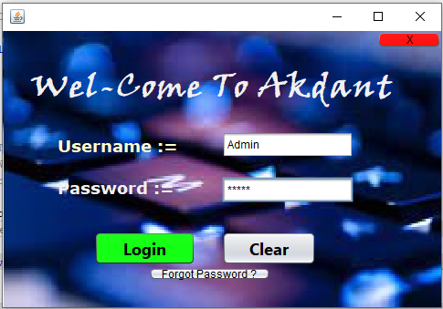

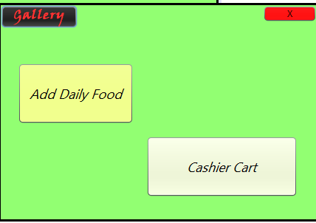

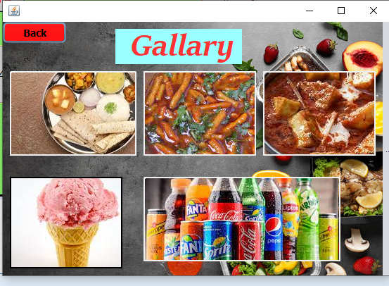

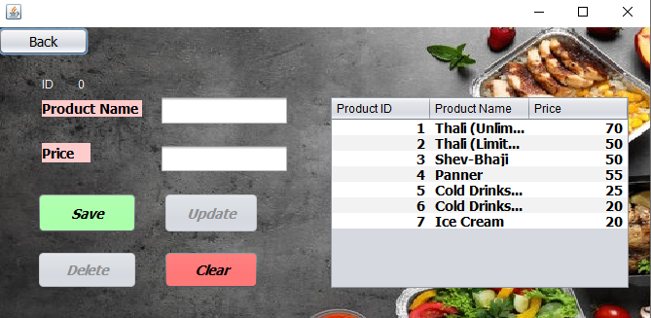

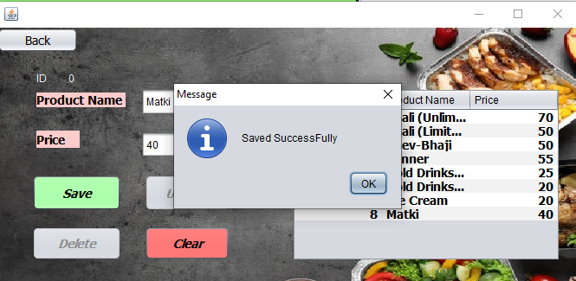

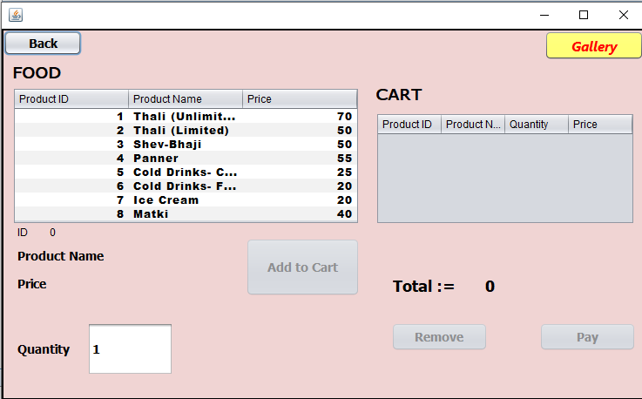

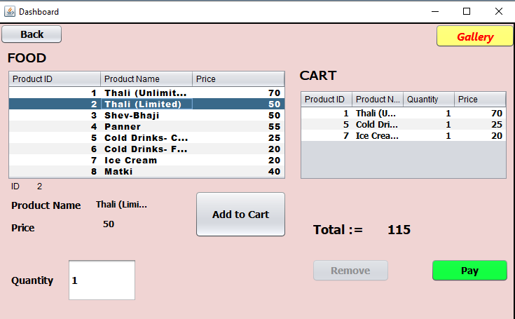

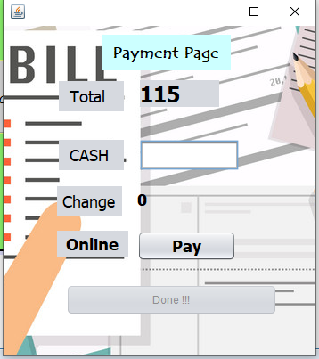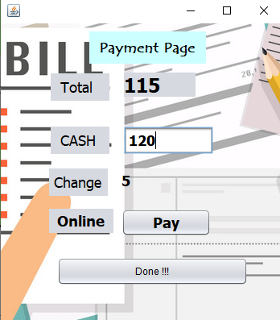

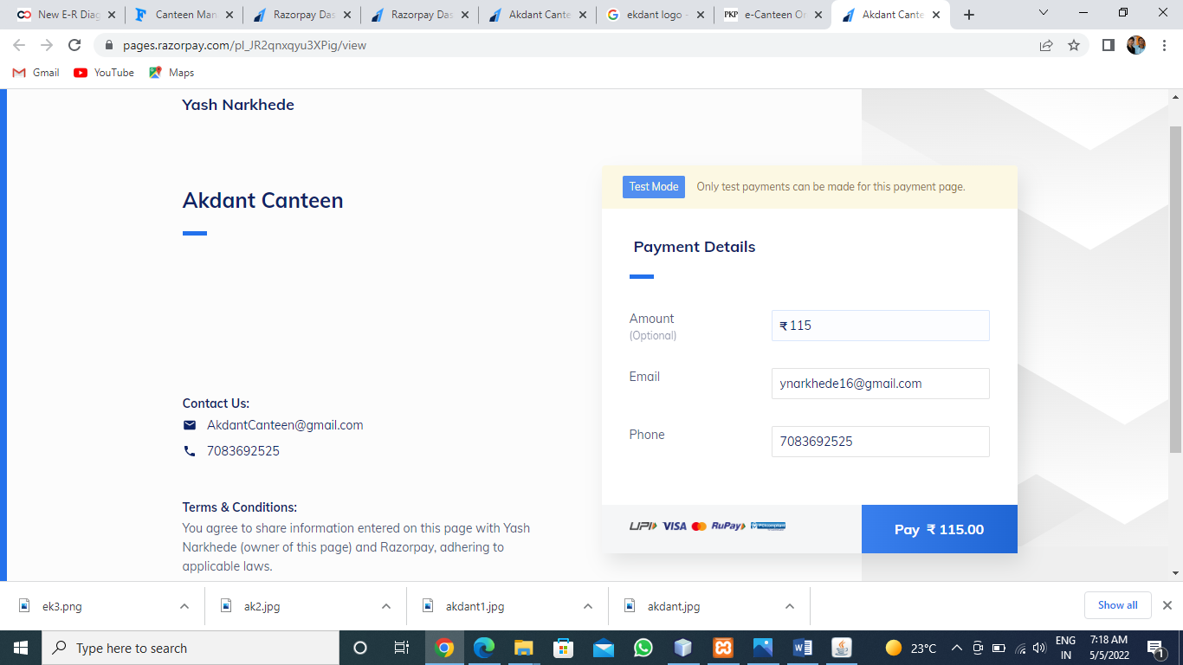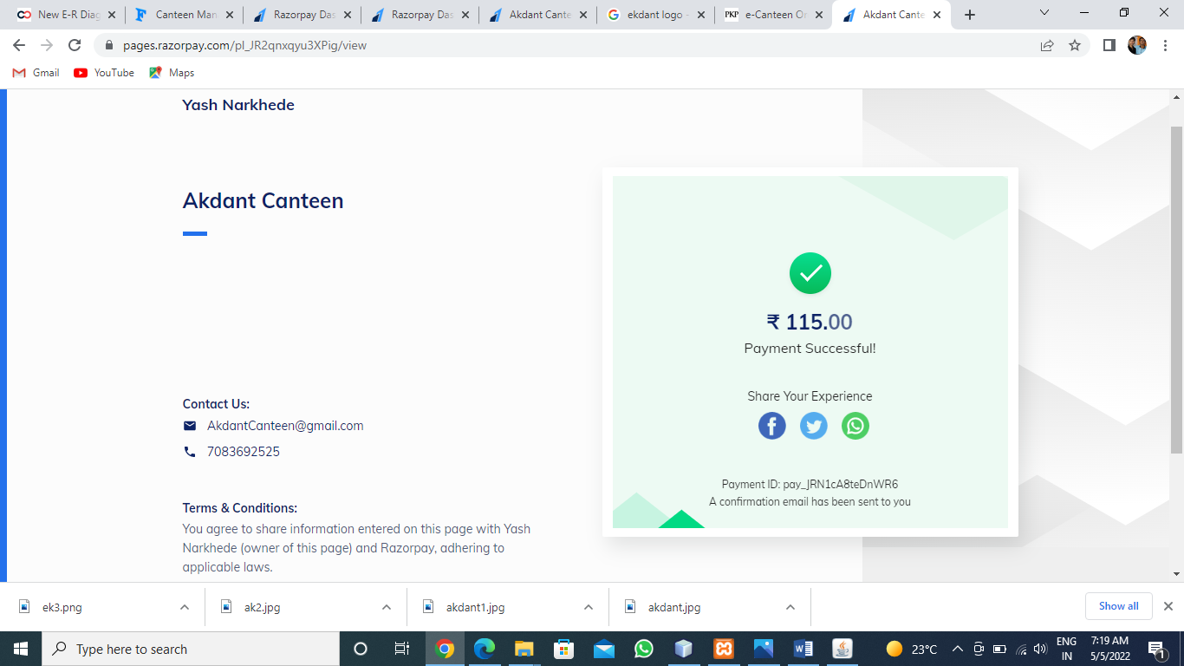

**User :**

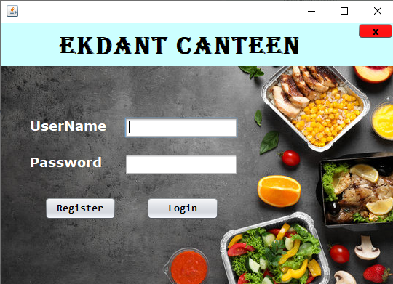

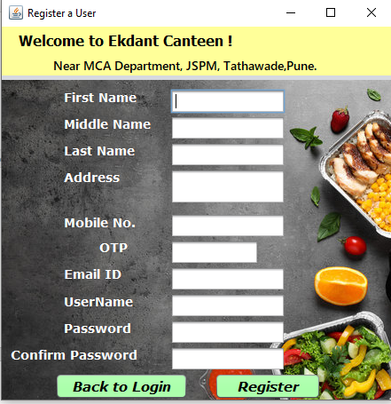









3) **Table specifications**

**Login :-**

|  |  |  |  |
| --- | --- | --- | --- |
| **Column Name** | **Data Type** | **Constraint** | **Description** |
| id | int (10) | Primary key | Id |
| username | Varchar(50) | NOT NULL | Feedback |
| password | Varchar(50) | NOT NULL | Password |
| fullname | Varchar(50) | NOT NULL | Full Name |

**Food Products :-**

|  |  |  |  |
| --- | --- | --- | --- |
| **Column Name** | **Data Type** | **Constraint** | **Description** |
| Id | int (10) | Primary key | Id |
| product | Varchar(50) | NOT NULL | Product |
| Price | Varchar(50) | NOT NULL | Price |

**User Registration** :-

|  |  |  |  |
| --- | --- | --- | --- |
| **Column Name** | **Data Type** | **Constraint** | **Description** |
| firstname | Varchar(50) | NOT NULL | First Name |
| middlename | Varchar(50) | NOT NULL | Middle Name |
| lastname | Varchar(50) | NOT NULL | Last Name |
| address | Varchar(50) | NOT NULL | Address |
| mobile | Int(11) | NOT NULL | Mobile |
| Email | Varchar(50) | NOT NULL | Email |
| username | Varchar(50) | NOT NULL | User Name |
| password | Varchar(50) | NOT NULL | Password |
| cpassword | Varchar(50) | NOT NULL | Confirm Password |

**Conclusion:**

This system can be implemented on small as well as large scale canteen business. We can Have track of orders and we can cook the food based on customer satisfaction and we give feedback form after delivery of food in application so the Chef can cook according to customer statisfaction.

**Bibliography**

**WEBSITES**

* [**www.javapoint.com**](http://www.javapoint.com)
* [**www.w3schools.com**](http://www.w3schools.com)